Kingdom: Anamalia
Phylum: Platyhelminthes
Class : Cestoidea
Subclass :Cestoda
Introduction
Is the name given to a class of parasitic flatworms, commonly called tapeworms, looking very much like a narrow piece of adhesive tape. Its members live in the digestive tract of vertebrates as adults, and often in the bodies of various animals as juveniles. Found all over the world, and exist in many different forms.
Mean features
* Tapeworms do not have a mouth like the fluke.
* Do not have a head or a digestive tract with digestive enzymes ,food is absorbed through the surface tegument whose surface is enlarged by microvilli.
* The ends differ, but neither has any organs or sensors that could be associated with what is commonly thought of being a "head." However, through a segment called a scolex, they are able to absorb predigested food.
* The scolex attaches to the intestinal wall by hooks or suckers.
* The body contains hundreds of segments (proglottids), and each is a sexually complete unit that can reproduce, if necessary.
* Some tapeworms have reached lengths of more than ten meters (thirty feet) with a lifespan, inside a host, of thirty years or more.
* Cestodaria is the unsegmented subclass of tapeworm affecting various fish and some reptiles.
* Tapeworms are dependent on two hosts for their development, one human and the other animal. Larvae are found in animal hosts, while the adult worm is found in humans. However, there are two species where this development is reversed. Echinococcus granulosis and E. multilocularis differ from other tapeworms in that it is the adult worm that infects an animal host, while the larvae form produces slow growing cysts in humans. This condition is known as Echinococcosis or Hydatid disease, which takes surgical intervention to remove the cysts.

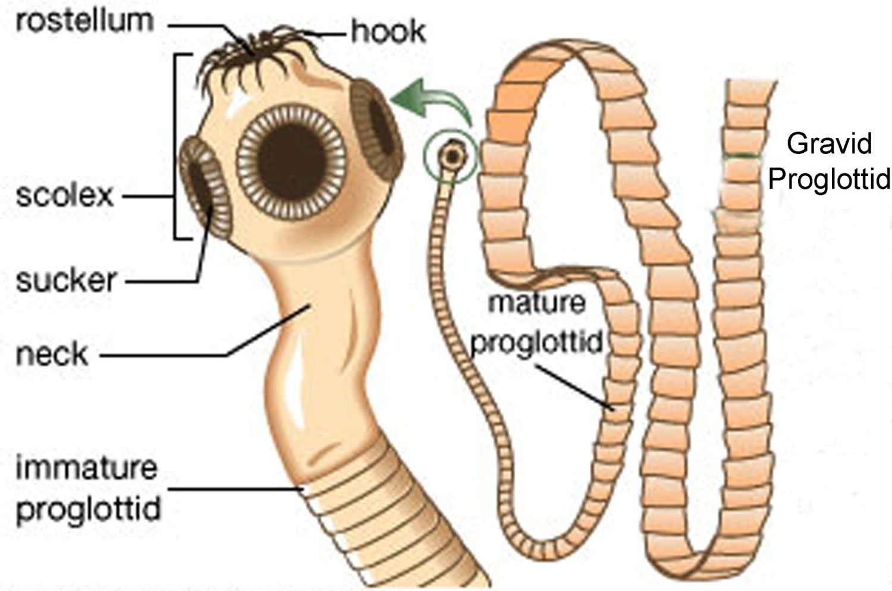
Typical morphology of cestoda

The hosts
The lifecycle of the tapeworm involves a definitive and intermediate host . Taenia solium and T. saginata are pork and beef tapeworms, respectively, whereas Echinococcus granulosus and E. multilocularis are dog tapeworms.
Canines and sheep are the definitive and intermediate hosts of E. granulosus. E. multilocularis is found in reservoir hosts such as dogs, wolves, and cats, with larval stages found in rodents.
D. latum is a fish tapeworm with two intermediate hosts, a copepod and a fish.
H. nana and H. diminuta are rodent tapeworms that use fleas and beetles as intermediate hosts .

Life Cycle
Basic theme:
1- Embryogenesis within the egg embryo (oncosphere or hexacanth).
2- Hatching of the oncosphere before or after being eaten by the next host penetrates to extraintestinal site.
3- Metamorphosis of larva into a juvenile metacestode – usually with a scolex.
4- Ingestion of metacestode development of the adult worm from the metacestode in the intestine of another or rarely the same host.
Adult tapeworms are found in the intestinal tracts of their definitive, or final, hosts. Each adult tapeworm consists of a head (scolex), which attaches the tapeworm to the intestinal wall, neck, and various numbers of segments, developing from the neck region. As new segments are formed at the neck, older segments are pushed back. Tapeworms are hermaphroditic; each segment has two sets of male and female reproductive organs, which will fill the segment with fertile eggs as the segment is pushed back from the neck. When the segment is full of eggs, it detaches itself from the adult tapeworm and is passed in the feces
Each genus and species of tapeworm has at least one intermediate host , which ingests the tapeworm eggs. After the eggs hatch, the immature tapeworms migrate out of the intestine of the intermediate host and travel to various tissues in the body, depending on the genus of tapeworm. The immature tapeworm enters tissue in the intermediate host and is enclosed in a cyst, in which young tapeworms develop to an infective stage. Definitive hosts are infected by eating the cystic tissues of intermediate hosts infected with immature tapeworms.

Body proper:

Scolex
The worm's scolex "head" attaches to the intestine of the definitive host. In some species, the scolex is dominated by bothria (tentacles), which are sometimes called "sucking grooves", and function like suction cups. Other species have hooks and suckers that aid in attachment. Cyclophyllid cestodes can be identified by the presence of four suckers on their scolex.
Proglottids
The body is composed of segments (proglottids). The sum of the proglottids is called a Strobila, which is thin, and resembles a strip of tape. From this is derived the common name "tapeworm". Each proglottid contains the male and female reproductive structures.
Like some other flatworms, cestodes use flame cells (protonephridia), located in the proglottids, for excretion. Mature proglottids are released from the tapeworm's posterior end and leave the host in feces.
Older segments are pushed toward the tip of the tail as new segments are produced by the neckpiece. By the time a segment has reached the end of the tail, only the reproductive tract is left. It then drops off, carrying the tapeworm eggs to the next host, since, in essence, each segment, by that point, the proglottid is simply a sac of eggs.

Cestoda systems
The main nerve centre of a cestode is a cerebral ganglion in its scolex. Motor and sensory innervation depends on the number and complexity of the scolex. Smaller nerves emanate from the commissures to supply the general body muscular and sensory ending. The cirrus and vagina are innervated, and sensory endings around the genital pore. Sensory function includes both tactoreception and chemoreception. Some nerves are only temporary. These are in the proglottids, and stop working with a detach.
Tegument
-Syncitium- cytons connected by trabeculae(cytoplasmic bridges) to distal cytoplasm.
-Microtriches-
-Glycocalyx-
Microtriches (singular microtrix) are the highly specialized microvilli covering the entire surface of the tegument of cestodes. They are: fine hair-like filaments distributed throughout the surface of the body.
All cestodes lack digestive and excretory systems, therefore, the tegument with its microtriches constitute the principal site of absorption of nutrients and elimination of waste materials. Moreover the microtriches are the primary structures for host-parasite interface, and are metabolically active performing all the vital activities such as sensory, absorptive and secretory functions. Thus their structural significance is clearly to amplify the total surface area of the tegument.
The surface carbohydrate complex called glycocalyx is responsible for inhibition of the host digestive enzymes, absorption of cations and bile salts, and enhancement of the host amylase activity. The acidic glycosaminoglycans of the glycocalyx are specific for inhibiting a number of digestive enzymes of the host.
The microtriches in cestodes increase the surface area of the teguments for enhanced absorption of nutrients. In addition, they act as sensory organs for detecting the surrounding environmental cues and primary target site of anthelmintic drugs.
The capacity of the tegument to absorb exogenous materials is proportional to the number and extent of pits or microtriches and the number of mitochondria in the distal cytoplasm.
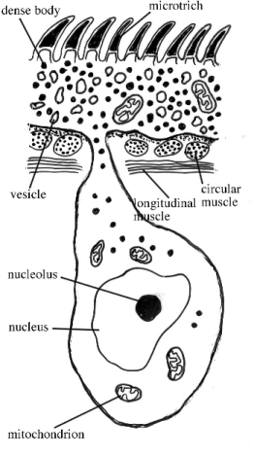
Section in sectode tegument

Parenchyma
The space enclosed by the tegument - except for the portion occupied by reproductive organs, osmoregulatory structures, muscle fibers and nervous tissue - is filled with a spongy tissue known as parenchyma .In live tapeworms, fluid fills the spaces between the parenchyma cells.
Parenchyma cells are the primary sites for synthesis and storage of glycogen. There is speculation that a single population of cells, the myoblasts, gives rise to both the parenchyma and the musculature of most tapeworms.
Nervous System
The scolex contains the primary nerve center for the tapeworm. The nerve centers consists of a complex of ganglia, commissures, and motor and sensory innervations. The simpler the holdfast structures associated with the scolex, the less complex the nerve center and vice versa. Longitudinal nerves extend posteriorly from the anterior ganglia. Small nerves arise from the longitudinal nerves to supply the body muscles and sensory endings. The vagina and cirrus are well-supplied with nerves and the genital pore has more sensory endings than other parts of the strobila. Sensory endings seem to include tactoreceptors and chemoreceptors.
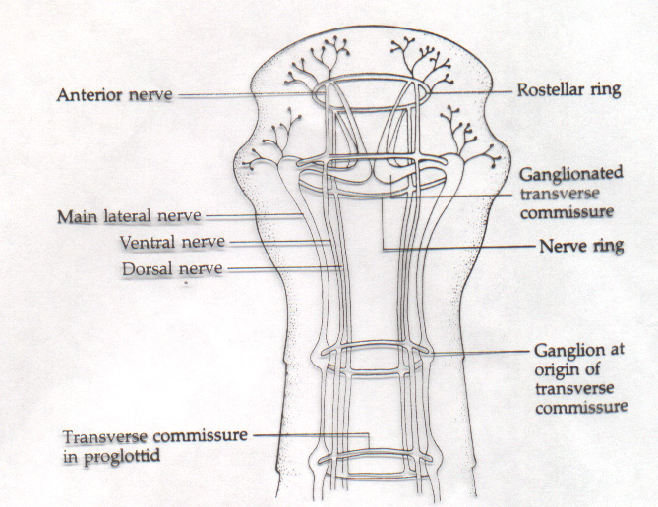
Nervous system of cestodes
The cords are connected in each proglottid by cross connectives and the small motor nerves emanating from the cords and cross-connectives innervate the reproductive organs and musculature, while small sensory nerves supplying the tegument merge with the cords and connectives.
Excretion and Osmoregulation
The cestodes have the protonephridial flame bulb system typical of the flatworms. a flame cell protonephridium and these are embedded throughout the parenchyma. The ductules of flame cells appear to be syncytial as opposed to being formed by a single cell.
The excretory ducts are lined with microvilli suggesting they are involved in transport, such as active transport of excretory wastes and they may also help to regulate ionic concentrations of the excretory fluid. When sampled, the excretory fluid has been found to contain glucose, soluble proteins, urea, ammonia, and lactic acid. End products of cestode metabolism , such as short-chain organic acids, are probably excreted through the tegument, not the excretory system. The tegument is also important in osmoregulation in cestodes.

Reproduction
True tapeworms are exclusively hermaphrodites; they have both male and female reproductive systems in their bodies.
The reproductive systems includes one or many testes,cirrus,vas deferens and seminal vesicle as male organs, and a single lobed or unlobed ovary with the connecting oviduct and uterus as female organs.
There is a common external opening for male and female reproductive systems, known as genital pore, which is situated at the surface opening of the cup-shaped atrium.
Even though they aresexually hermaphroditic, self- fertilization is a rare phenomenon. In order to permit hybridizaition, cross-fertilization between two individuals is often practiced for reproduction. During copulation, the cirrus of one individual connects with that of the other through the genital pore, and then exchange their spermatozoa.
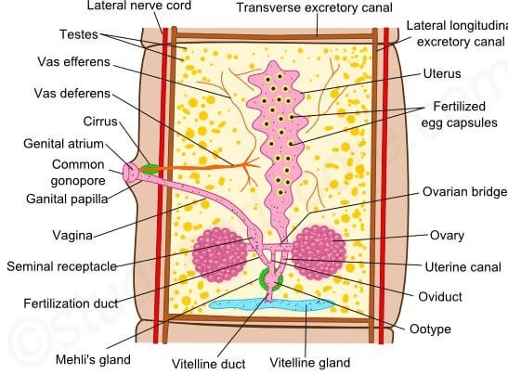
Reproductive system in cestoda

Male Reproductive System
Consists of one to many testes embedded in the medullary parenchyma of each proglottid , and emanating from each testis is a single vas efferens.In cases of multiple testes, the vas efferentia unite to form a common vas deferens, which is usually coiled. The distal portion of the vas deferens is modified as a muscular cirrus, usually enclosed within a cirrus sac .
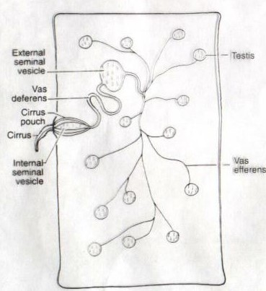
Male reproductive systems

In some species, the cirrus is equipped with spines that hold the organ in place during copulation. The cirrus everts through the male genital pore, which in turn, opens into the common genital atrium.
In most species there is an enlarged area of the vas deferens, the seminal vesicle, for the storage of sperm. When located within the cirrus sac, it is designated an internal seminal vesicle; when outside the sac, it is termed an external seminal vesicle.
Female Reproductive System
Ova are produced in a single, sometimes bi-lobed ovary. Following fertilization, the resulting zygote passes into a region of the oviduct, the ootype, equipped with structures involved in eggshell formation.
Mehlis’ gland surrounds the ootype and secretes into it material essential to the formation of the egg shell. A single common vitelline duct enters the oviduct in the vicinity of the ootype. Common vitelline duct is formed by the union of many primary vitelline ducts arising from vitelline glands.
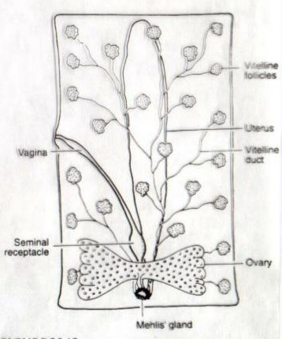
Female Reproductive System

Vitelline glands (=vitellaria) may form a compact body or consist of numerous follicles scattered throughout the medullary parenchyma. The vagina carries sperm from the genital atrium to the oviduct, and fertilization occurs in the region where the vagina and oviduct join. Sperm is stored in an enlargement of the vagina known as the seminal receptacle.
The Egg
The oncosphere (larvae within the egg), containing 3 pair of hooks, is encased in an inner envelope that in turn is surrounded by another membranous structure, the embryophore . A cellular zone known as the outer envelope lies between the embryophore and the shell (capsule), usually the outer most covering of the egg.
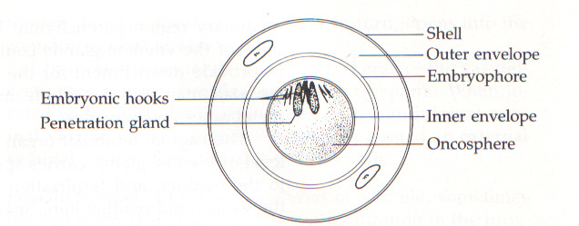
Egg of cestoda

